Appetizers
Pita bread and hummus 4.00
Vegetable sticks and dip 4.00
Chicken Wings - 8 pieces 7.00
4 Mini wraps 4.00
Fish fritters and dip 6 pieces 4.00

Main Meals

$9.00 for all meals Baked Chicken
Jerk Chicken (veg option available) Fried Fish or steamed
*Meals come with 2 sides

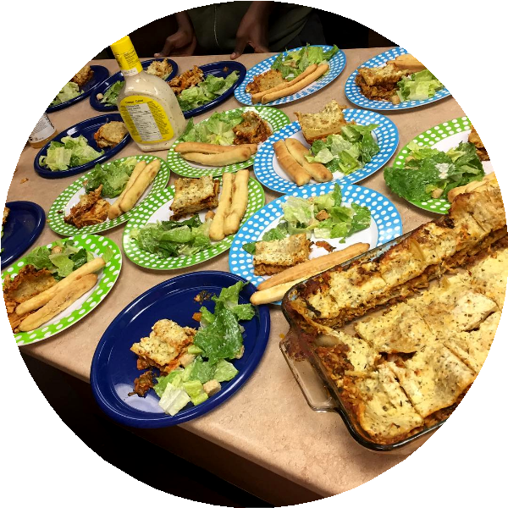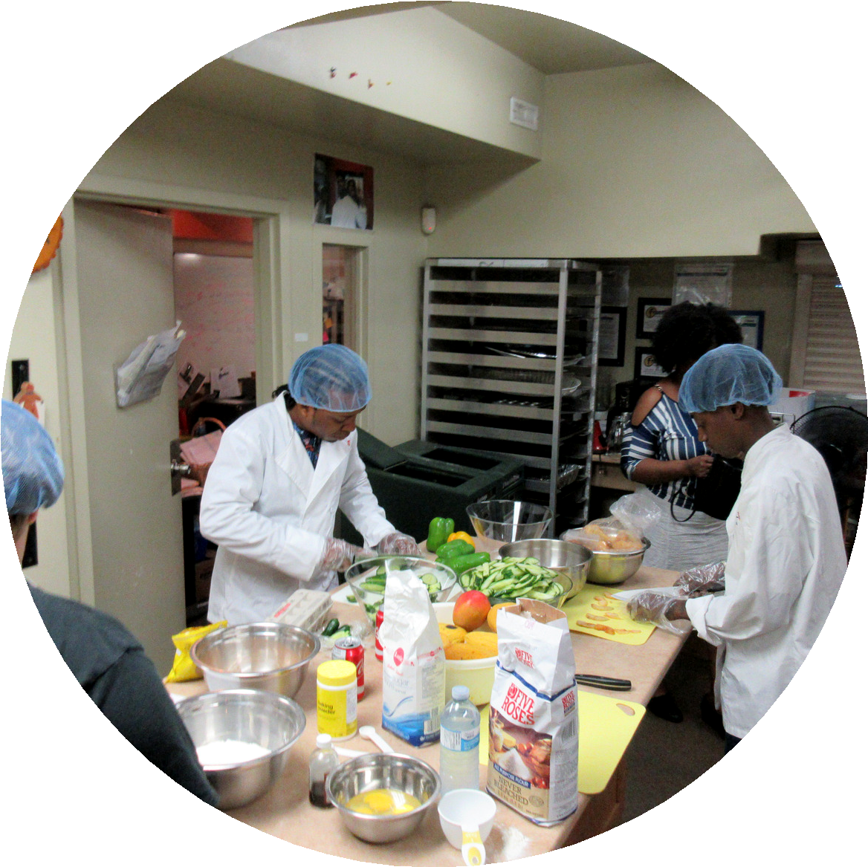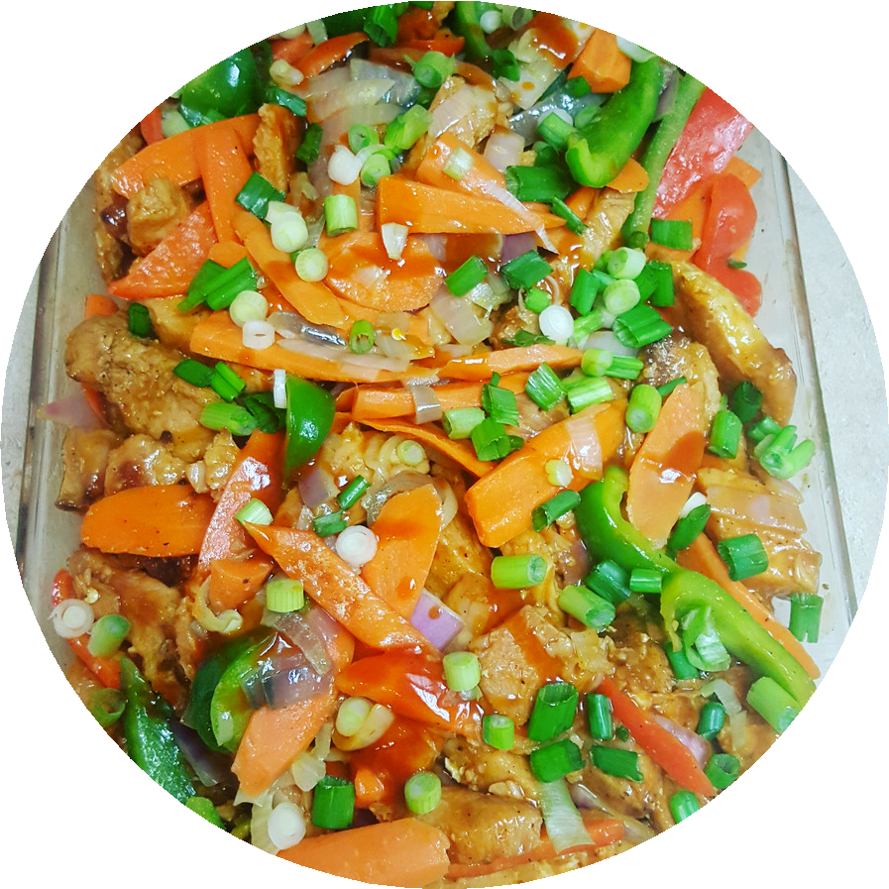Casseroles Individual Serving

Lasagna 6.00
Mac n’ Cheese 5.00
Quiche – Eggs + Spinach 5.25
Scalloped Potato Cass 4.50
Pulao (rice, peas, chicken and veg) 7.00

Soups
$5.00 for all soups
Vegetable Beef Chicken

Salads - Individual Servings
$4.00 excepting $5.75 for Mango Crunchy Tossed Salad
Macaroni Creamy Coleslaw Potato
Mango Crunchy

Sides

Steamed rice Stir fried pasta Mashed potatoes
Seasonal vegetables Steamed corn

* Salads available as substitutes

Other items outside this menu available

Frontlines Youth Culinary Program 416-244-7017
www.frontlines.to

Desserts - Individual Sevings

Apple Cake 6.00
Fruit cup 4.00
Cheesecakes:
Mango, Strawberry or chocolate 5.00
Cupcakes
Vanilla chocolate or marble 2.50
Waffles:
Topped with fresh fruit and syrup 5.00
Bread pudding with sauce 4.00

Drinks
$2.50 for all drinks Iced tea
Lemonade Fruit Punch

