Are you a Woman/Trans-woman Living with HIV?
Meet & Learn at the:

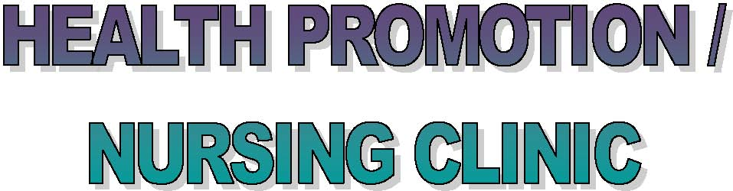

Hassle Free Clinic, in collaboration with PWA & Casey House
invite you for the twice monthly drop-in trans-inclusive HIV+ Women’s Health Promotion/Nursing Clinic. Learn, socialize, and share your knowledge the first & third Wednesday of every month on women’s health issues from a harm reduction perspective in a safe, confidential space.

*Some opportunity for individual nursing consultation*

Date: Wednesday 7 June, 2017
Time: 1.30 – 3.30pm

Topic: Treatment Adherence & Side Effects
*Kyle Vose*

Location: PWA, 200 Gerrard St E. 2nd Floor

For More Information contact:
esther@hasslefreeclinic.org or call Esther on 416 922 3549 ext. 123

Childcare Subsidy available upon proven eligibility
Tokens available upon request

